|  |
| --- |
| Off Shore Mexico Project (Hokchi Field & Other areas operated by Hokchi) |
| Casing and Tubulars  General specification &  Quotation Request |



Contents Table

1 Introduction 3

2 General Wells geometry 4

2.1 Hokchi field 4

2.2 Other areas operated by Hokchi 5

3 Technical Requirements 8

3.1 API 5C5 CAL specifications for Hokchi field 10

4 Technical integrity 10

5 Shipping 10

6 Labeling and Marking Instructions 10

7 Technical questionnaire 11

8 List of materials and specifications 12

# Introduction

The company is planning the production stage in the field called “Hokchi” through the drilling of 9 new wells and completion for 5 finished wells, in the marine basin of Southern México, with 27 m of water depth and a distance from the block to the Dos Bocas port, Tabasco, of 27 km.

The company is also planning an exploration stage in others fields operated by Hokchi Energy, through the drilling of a well in GoM, in the marine basin of Southeastern México, with 19 m of water depth and a distance from the block to the Coatzacoalcos port of 6 km. The figure 1 shows the location of other areas.

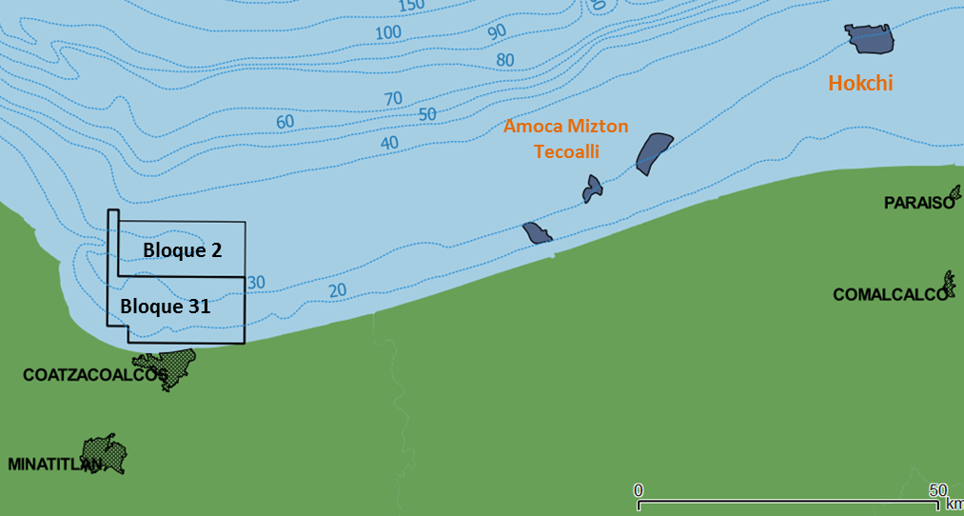

*Imagen 1: Ubicación propuesta para el prospecto, pozos vecinos y pozos de correlación analizados*



Regarding the Hokchi other areas, the closest city and logistics base is Coatzacoalcos in the state of Veracruz, GoM and regarding Hokkchi the closest City and available dock is “Dos Bocas” in Paraíso City state of Tabasco.

* Wellhead system: dry surface wellhead with mudline suspension system.
* Water depth:; 25-27 m (Hockchi); 18-21 m (Other areas);
* Tensioner deck: 15 m above sea level.
* Rotary table: 32 m above sea level.

# General Wells geometry

## Hokchi field

The campaign considers two well design cases:

* Type “A”: 30” x 20” x 13.3/8” x 9.5/8” liner x 7” liner

Tieback for 9.5/8” casing, 11.3/4” and 5” liner will be only used un contingency (red colour)

* Type “B”: 30” x 20” x 13.3/8” x 11.3/4” liner x 9.5/8” liner x 7” liner

Tieback for 9.5/8” and 5” liner will be only used un contingency (red colour)



Hokchi design Type A



Hokchi design Type B

## Other areas operated by Hokchi

Exploration campaign considers a well with this design options:

1. Base case: 30” x 20” x 13.5/8” x 9.5/8”
2. Case contingency with 20” casing: 30” x 20” x 16” x 13.5/8” x 9.5/8”
3. Case contingency with 13.5/8” casing: 30” x 20” x 13.5/8” x 11.7/8” x 9.5/8”
4. Case contingency with 9.5/8” casing: 30” x 20” x 13.5/8” x 9.5/8” x 7.5/8”



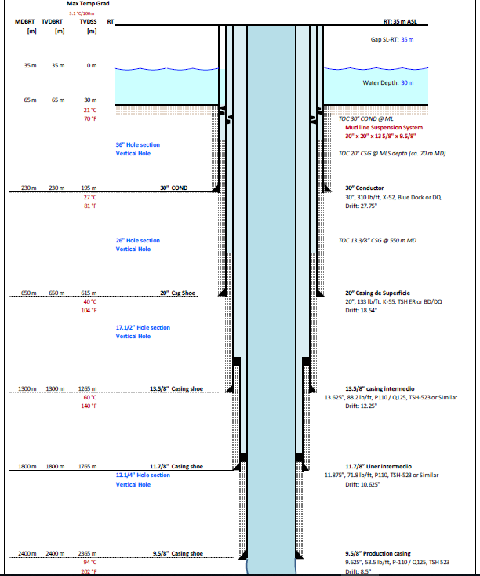

# Technical Requirements

1. Pipe shall meet the requirements of the following API standards:

|  |  |
| --- | --- |
| CASING / TBG | API STANDARD |
| 30” | API SPEC 5L "Line pipe" 46 th, , Last edition  API SPEC 5C6 "Pipe with Welded Connectors" , Last edition |
| Sizes < 30” | API SPEC 5CT "Casing and Tubing" , Last edition  API SPEC 5C5 "Procedures for Testing Casing and Tubing Connections", Last edition |

1. Because of storage limitations space on Rig, casing shall be Range 3 length **limited to 13,9 m.**
2. Vendor shall submit the mill certificates/material certification of the pipe being offered
3. Where pre-existing pipe is being offered, tenderer shall submit pipe inspection reports and details of manufacturing.
4. All tubulars must be sent with thread protectors installed and thread protectors shall be recovered by vendor
5. All tubulars must be drifted with API Teflon rabbit provided by Casing and Tubular vendor. Drifting operation can be performed by rig crew.
6. Vendor must provide all the lifting subs for each provided connection and has to provide enough quantity to ensure operation continuity.
7. Vendor shall include lifting subs drawing and lifting capacity on technical offer.
8. Specialist Tubular rig site supervisor service must be provided by Vendor to guarantee handling, make up - breakout operation, make up torque control and all Vendor’s procedures are correctly accomplished and followed.
9. Tubulars supervisor on rig site must perform random measurement (10% of the tubulars to be run) to the casing length, Pin ID & Box ID and those measurements must be reported to the Well Site Drilling Engineer, Co Man and Sr Drlg Engineer for cementing calculation.
10. All vendors equipment provided in connection with the supply shall be suitably slung accompanied with a packing list detailing contents together with serial numbers where appropriate.
11. Vendor shall ensure that fumigation of all wood products used in the packaging of the goods is carried out for import into Mexico, whenever applicable.
12. All materials and tools shall be delivered to the harbor of Dos Bocas, Tabasco, or Coatzacoalcos, Veracruz, labeled and packed for proper offshore transportation according to the following standards:

* BS 1290:1983 (specification for wire rope slings)
* BS 6210:1983 (safe use of wire rope slings)
* BS 1133-8:1991 (wooden boxes, cases and crates)
* BS EN 12079:2006 or equivalent (offshore containers)

1. The quotation shall list detailed cost per component.
2. The quotation shall detail lead time for each item. Vendor shall specify delivery time from purchase order signature or other partial compromises (specify which).
3. Specialist rig site supervisor must be quoted and 5 days must be considered.
4. A book or manual with detailed instructions for casing handling and connection (& connectors) operation shall be supplied in advance of actual delivery of materials, both in paper and digital formats.
5. Water bushing shall be constructed under API 5CT 9th Edition. Vendor shall include on technical offer drawings and lifting capacity. Vendor shall consider dimensions guidelines as follows:
6. Crossover connectors shall meet the dimensional requirements of Figure 1. If the dimensional requirements of Figure 1 cannot be met, the Manufacturer shall submit drawings and appropriate calculations for approval by the Purchaser.
7. The Manufacturer shall give due consideration to the crossover design if the purchase agreement or Crossover Data Sheet specifies a hydraulic control line allied to the crossover.
8. The crossover shall have adequate length and external features to allow the application of proper make-up tools. When specified on the purchase agreement, the length of the crossover shall be sufficient to allow at least one re-cut of the connection and still maintain the requirements of Figure 1.

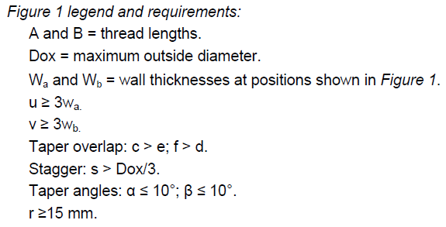

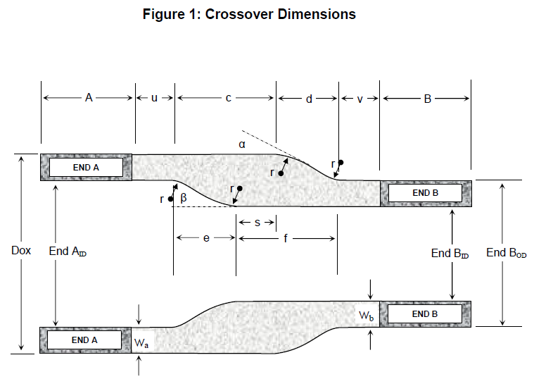

NOTE: As required length is 1,2 m (4 ft), for 30 and 20 inch water bushings, beta and alpha angles can be higher than 10°:

For 30” water bushings angles can be around ~60°

For 20” water bushings angles can be around ~45°

## API 5C5 CAL specifications for Hokchi field

Casing and Tubing shall fulfill requirements for API RP 5C5 “Procedures for Testing Casing and Tubing Connections” 4th edition.

Vendor shall indicate on offer wich CAL category (I, II, III or IV) is considering for each casing or tubing offered.

|  |  |  |
| --- | --- | --- |
| **CASING SIZE** | **CONNECTION** | **REQUIRED CAL** |
| 20” - 16” | Premium – Gas Seal | CAL Category for Gas tight connection |
| Size<16” (13.5/8”, 13.3/8”, 9.5/8”, etc) | Premium – Gas Seal | CAL IV |

Depending on well design, tubing specifications will be as follows:

|  |  |  |
| --- | --- | --- |
| **TBG** | **CONNECTION** | **REQUIRED CAL** |
| 3 ½’’ 10.3 LBS/FT C110 | Premium – Gas Seal | CAL II & IV |
| 4 ½’’ 15.1 LBS/FT L80 | Premium – Gas Seal | CAL II & IV |
| 5 ½’’ 23 LBS/FT L80 | Premium – Gas Seal | CAL II & IV |

# Technical integrity

All Materials supplied against a purchase order ensuing from this Request for Quotation may be subject to inspection by COMPANY’s Nominated Third Party Inspection Body (NIB) during manufacture.

# Shipping

All preparations for shipping offshore shall be compline with Standard practices from North West European Area Guidelines (NWEA) and Guidelines for Offshore Marine Operations (GOMO). Appendix “handling of tubular cargo”.

# Labeling and Marking Instructions

Marking and color coding shall be as specified in API 5CT and detailed in the Purchase Order.

All documents are to be clearly marked with Shipping Mark and the Purchase Order Number.

E.G. Markings:

P.O. N° .

Nominal OD:

Lb/ft:

Total Wt: Lb or Tn

Dim: (width: length: Height: ) meters

Description:

# Technical questionnaire

Suppliers shall answer the following questions 1-5 in the table below precisely and succinctly:

|  |  |  |
| --- | --- | --- |
|  | **Question** | **Supplier response** |
|  | If pipe is being manufactured, identify location of manufacture, location of thread preparation and lead time for completion.  In addition, please identify delivery point for the quoted price and lead time to have pipe available at stated delivery point.(See quotation sheet) |  |
|  | For pre-existing pipe, please identify current location of pipe, delivery point for the quoted price and lead time to have pipe available at stated delivery point.  Also, please outline “life-history” of the pipe including the age of the pipe, where it was manufactured, and where/how it has been stored. |  |
|  | Give technical details of the gas-tight premium connection(s) quoted with the casing. Tenderers must include connection burst, collapse and tensile ratings, make-up thread loss, OD and ID. |  |
|  | Indicate the nearest location to Dos Bocas port where the casing threads can be re-cut. |  |
|  | Indicate the nearest location to API Cotzacoalcos port where the casing threads can be re-cut. |  |
|  | Indicate whether excess casing can be returned to tenderer and condition prices. |  |

# List of materials and specifications







